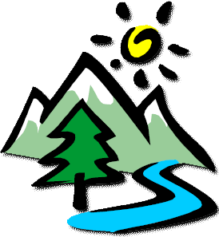
What to Bring – Label everything with your family name – Check the weather to be prepared!
Show your theme spirit throughout the weekend – (optional)
- Sleeping Bag / Bedding for twin bed and a sheet to cover the mattress.
- Pillows
Veteran campers also recommend:
- Clothes pins to close the curtains to block the sun
- Games / toys for the cabin and for family time
- Shower shoes
- Inflatable twin air mattress
- Coffee mug, coffee pot of the cabin, Aluminum water bottles, ice chest with water/drinks, snacks for kids. Stay hydrated!
- Trash & recycle bag in room
- Paper towels and soft soap to put in the bathroom
- Earplugs
- Small day pack for each child, refillable water bottle, Chap Stick, hat, light jacket if weather requires (all labeled with your name).

- Boots, Tennis Shoes
- Bath Towel and Toiletries
- Flashlight and Batteries
- Rain Jacket, Jacket for evening
- Hat, Sunscreen, Bug Repellent
- Water Bottles and Snacks
- Camera, charger/batteries
- Baseball Mitts, Balls, etc.
- Cochlear Implant Charger, Extra Hearing Aid Batteries, etc. (if applicable)
- All-Weather Clothes (warm & cold weather clothing as weather conditions are unpredictable)
- Swim Suit (there is a possibility the pool will be ready and warm enough to swim in)
- Special instructions will be emailed related to the theme of camp.

YMCA Rules
In order to ensure both a fun a safe time at Family Camp, the YMCA has asked us to observe the following rules:

- All YMCA activities areas are off-limits unless supervised by trained YMCA Camping Services staff member. These activities include but are not limited to Archery, Boating, the Climbing Tower, Riflery, and the Pool.
- Pets are not allowed at camp (with the exception of service dogs).
- No swimming in Lake Jessop.
- Alcohol is not permitted on camp property.
- Please refrain from parking or unloading on any roads because they are designated fire roads.
- The speed limit in camp is 10 m.p.h.
- Smoking is only permitted on paved areas (camp roads and parking area). Due to the threat of fire danger, smoking is not permitted in any buildings or in the forest.

