California Hands & Voices
Inland Valley DHH & Microtia Atresia Family Camp Round Meadow in Angelus Oaks, CA

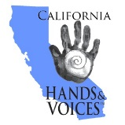

Photograph & Videotape Release
I, ___________________________________ give permission for our family to be photographed and/or videotaped by staff during the Inland Valley DHH & Microtia Atresia Family Camp. I understand the photos and/or videos may be used for information, promotional or instructional purposes. I also understand the photos and/or videos may be posted on the organization website, Facebook, Instagram, Twitter, or any other social media site.
Other Family Members:

Medical Information
Does any member of your family have any health issues that staff should be aware of (e.g. allergies to food, insect stings, or medical conditions)? Is there any reason to restrict the activities of your child(ren)? If so, please list:

Parent Signature Date

